**Set-up and execution of Ethereum Blockchain Project “Mobiles Purchase Shop”**

**Version: 1.0**

Table of Contents

**I.** **Verify the Project’s Pre-requisites:** 3

**1)** **Check the availability of Nodejs, NPM, and Truffle in your Windows Terminal** 3

**2)** **Check the availability of Ganache in your System** 3

**3)** **Check the availability of Metamask as the extension of your Chrome Browser and also the availability of “Ganache Test Network” in the Metamask Wallet** 4

**II.** **Setup the “Mobiles Purchase Shop” project in Windows System** 8

**1)** **Check the availability of Project files in your project folder and confirm** 8

**2)** **Open the Windows Terminal and change over to the Project Folder, list the directory and confirm the availability of Project Files** 8

**3)** **Execute the command “npm Install” and verify the availability of “node_modules” directory** 9

**III.** **Compile and deploy the “Mobiles Purchase Shop” Project** 10

**1)** **Compile the contract files and verify the creation of “build” directory** 10

**2)** **Start the Ganache Test Blockchain** 12

**3)** **Start and unlock the Metamask Wallet. Select “Ganache Network”. Import the first account of Ganache Test Blockchain and confirm** 12

**4)** **Deploy the contracts on to Ganache Test Blockchain and verify** 19

**IV.** **Start the Dev Server and verify the deployment of the project’s frontend** 23

**1)** **Start the Dev Server (lite-server)** 23

**2)** **Verify the display of the Project’s frontend in the Chrome Browser** 24

**V.** **Interactions with the “Mobiles Purchase Shop” Project using the frontend** 24

**1)** **Purchase a “Mobile” using the currently connected Ethereum Account** 24

**a)** **Click on “Purchase” button given under any one of the Bike pictures** 24

**b)** **Check on the Metamask account displayed and make sure that your recently imported account is displayed and it is loaded with 100 Ethers.** 25

**a)** **Now, click on “Purchase” button given under any one of the Bike pictures** 31

**b)** **Verify the Metamask Wallet display (like Account Info, Estimated Gas Fee, Total Fees) and then click on “Confirm” button.** 31

**c)** **Verify that the clicked “Purchase” button is changed to “Success”. The Ethereum Account info is displayed under Purchaser.** 33

**d)** **Verify the Ganache TX COUNT, Transaction and New Block Creation** 33

**2)** **Purchase a second “Mobile” with the same Ethereum Account** 35

**a)** **Click on “Purchase” button below any of the Mobile pictures which has not been purchased so far** 35

**c)** **Verify that the “Purchase” button has changed into “Success”.** 37

**d)** **Verify the Ganache TX COUNT, Transaction and New Block Creation** 37

**3)** **Purchase a “Mobile” with the another Ethereum Account** 39

**a)** **Copy the Private key of the Second Ethereum account in Ganache** 39

**b)** **Select the “Ganache Network” in the Metamask, import an account, paste the just copied Private Key and click on “Confirm” button** 40

**b)** **Click on “Purchase” button given under any one of the Mobile pictures which has not been purchased so far** 48

**c)** **Click on “Confirm” button in the Metamask** 49

**d)** **Verify that the “Purchase” button has changed into “Success”** 50

**e)** **Verify the Ganache TX COUNT, Transaction and New Block Creation** 51

# **Verify the Project’s Pre-requisites:**

# **Check the availability of Nodejs, NPM, and Truffle in your Windows Terminal**

**node -v**

**npm -v**

**truffle version**

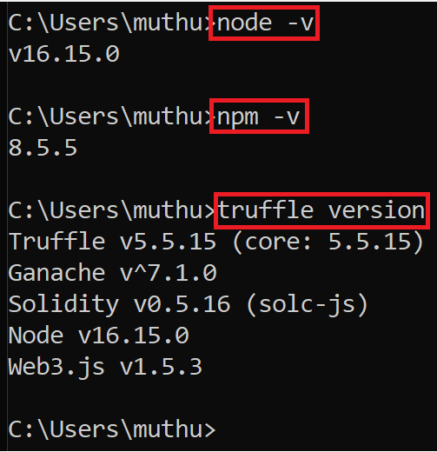

# **Check the availability of Ganache in your System**

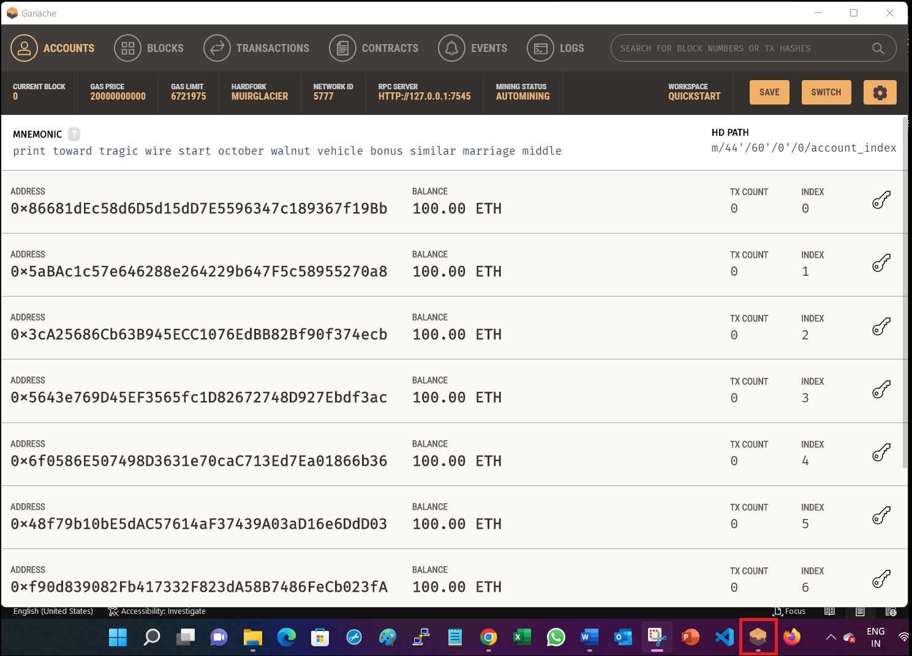

# **Check the availability of Metamask as the extension of your Chrome Browser and also the availability of “Ganache Test Network” in the Metamask Wallet**

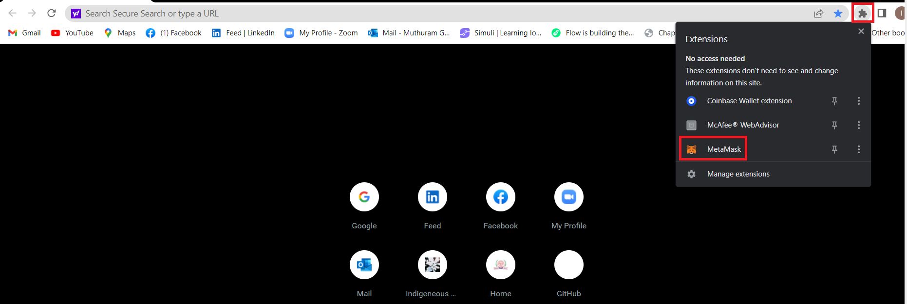

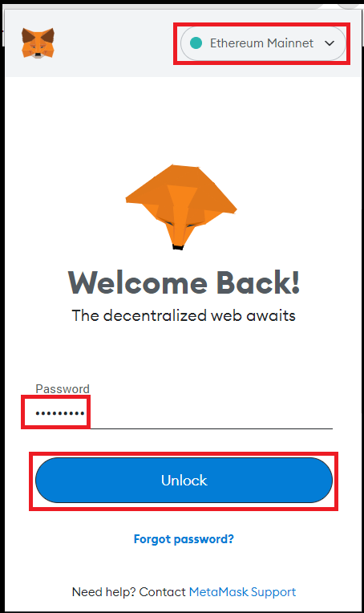

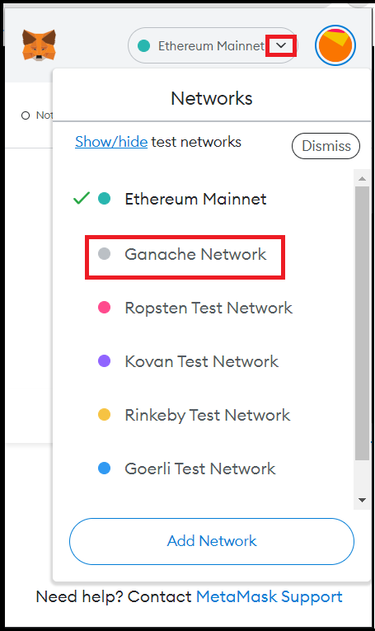

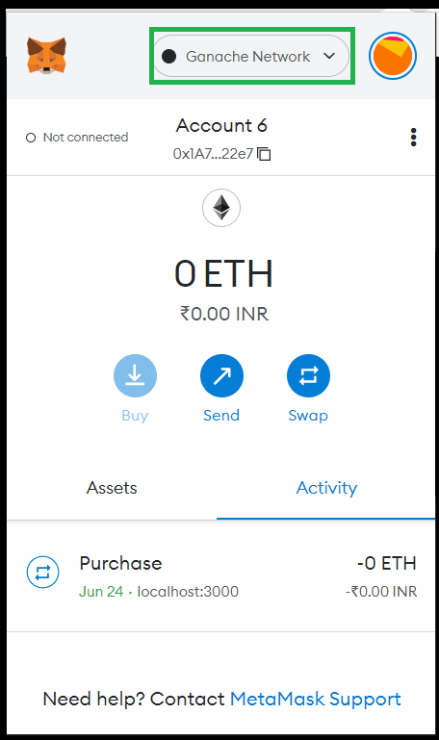

# **Setup the “Mobiles Purchase Shop” project in Windows System**

# **Check the availability of Project files in your project folder and confirm**

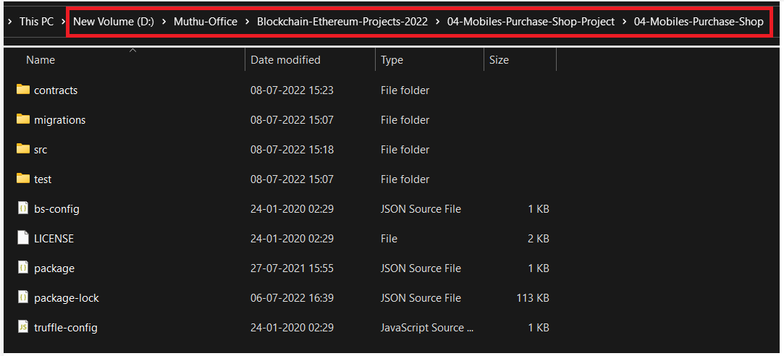

# **Open the Windows Terminal and change over to the Project Folder, list the directory and confirm the availability of Project Files**

**cd D:\Muthu-Office\Blockchain-Ethereum-Projects-2022\04-Mobiles-Purchase-Shop-Project\04-Mobiles-Purchase-Shop**

**d:**

**dir**

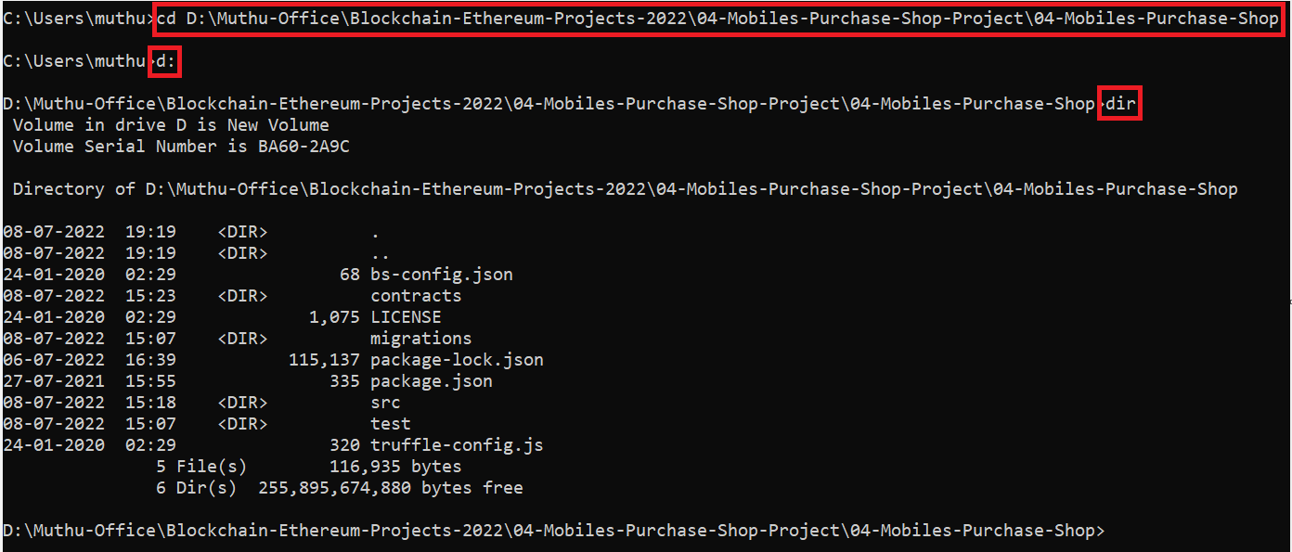

# **Execute the command “npm Install” and verify the availability of “node_modules” directory**

**npm install**

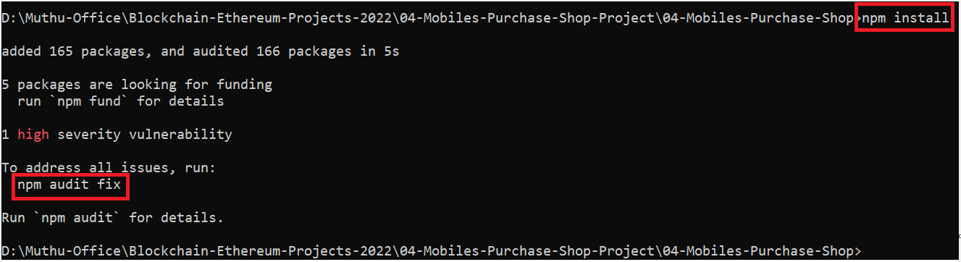

**npm audit fix**

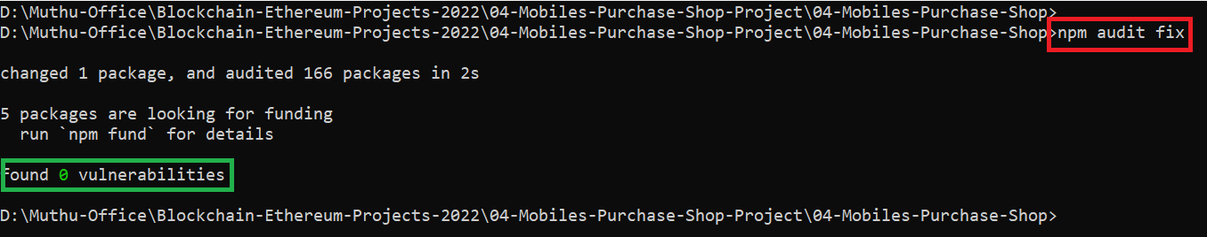

**dir**

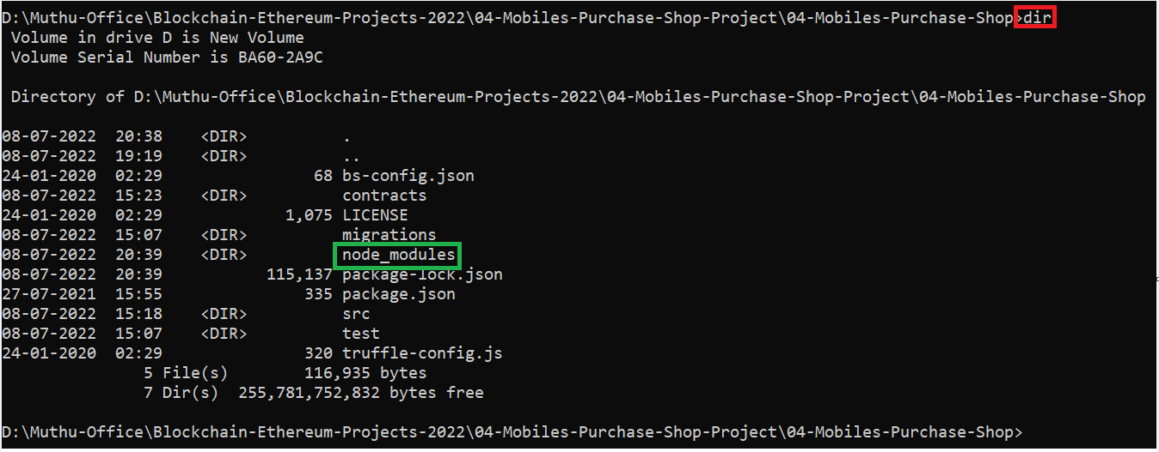

# **Compile and deploy the “Mobiles Purchase Shop” Project**

# **Compile the contract files and verify the creation of “build” directory**

**truffle compile**

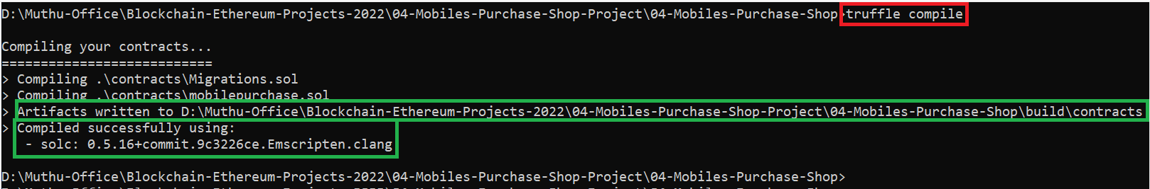

**dir**

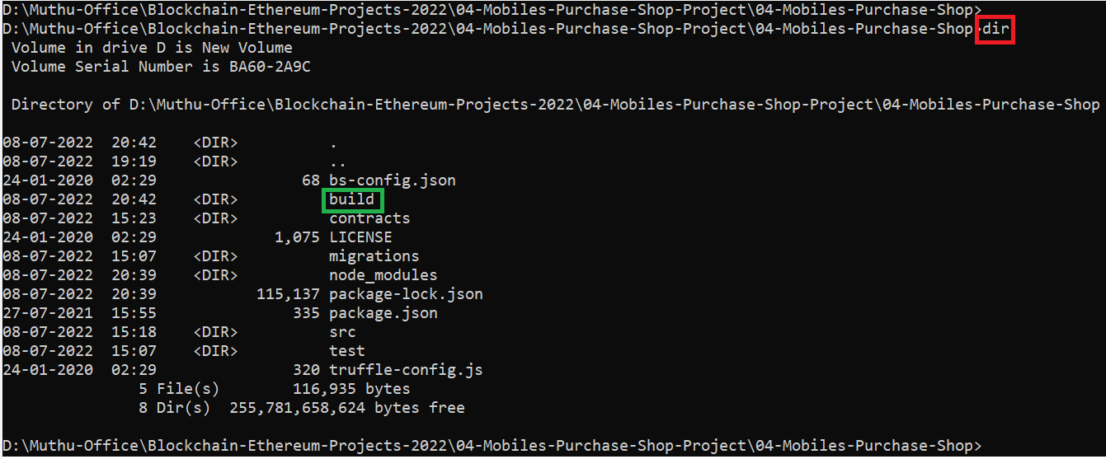

**cd build/contracts**

**dir**

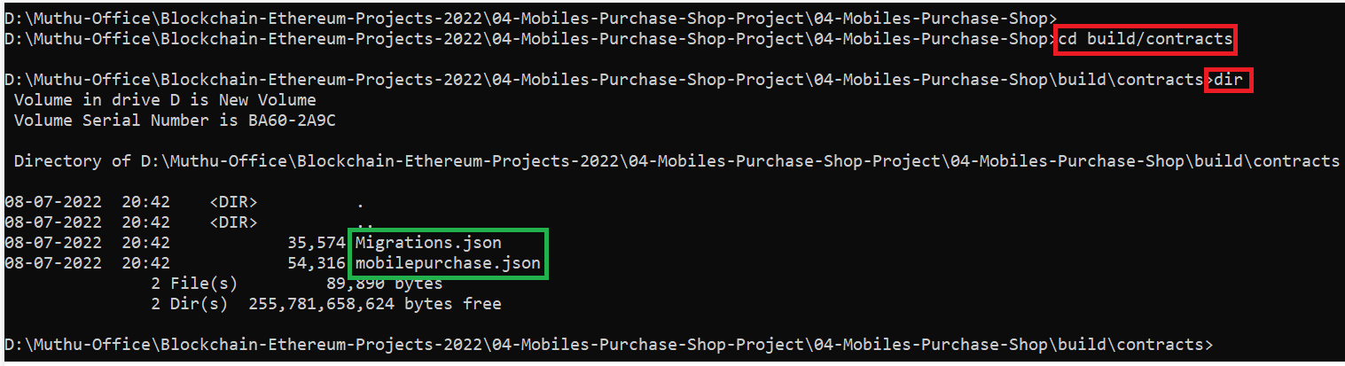

# **Start the Ganache Test Blockchain**

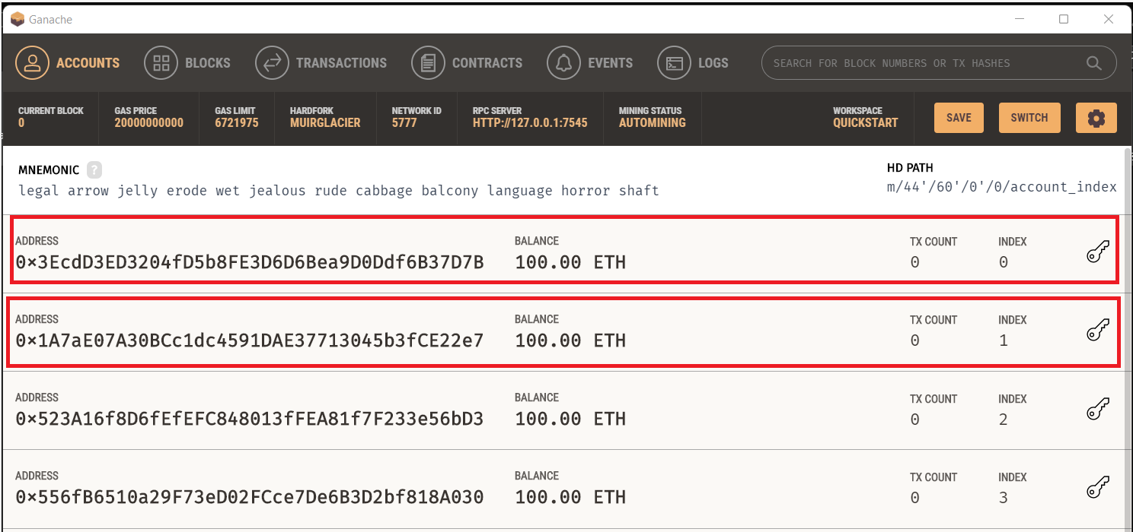

# **Start and unlock the Metamask Wallet. Select “Ganache Network”. Import the first account of Ganache Test Blockchain and confirm**

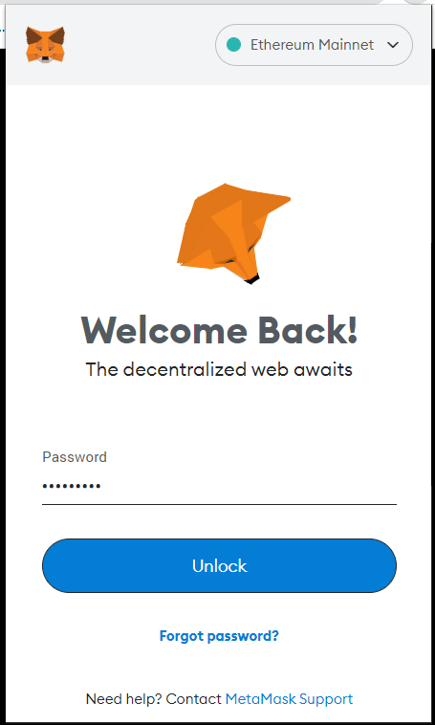

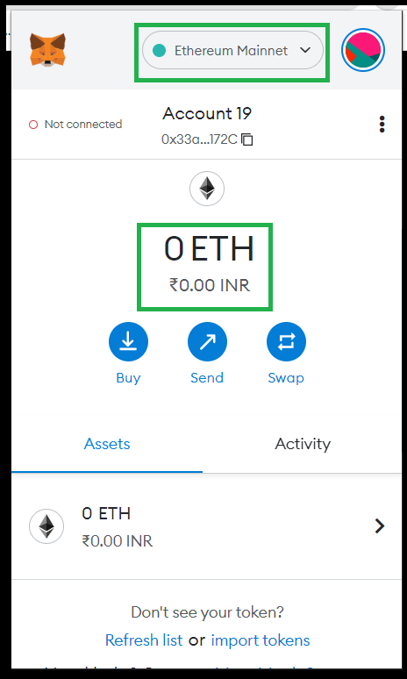

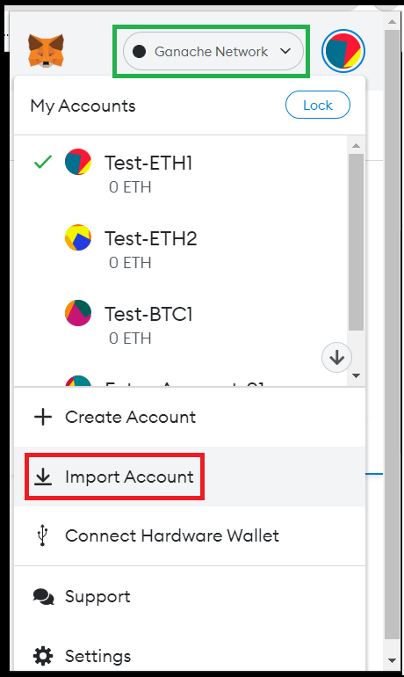

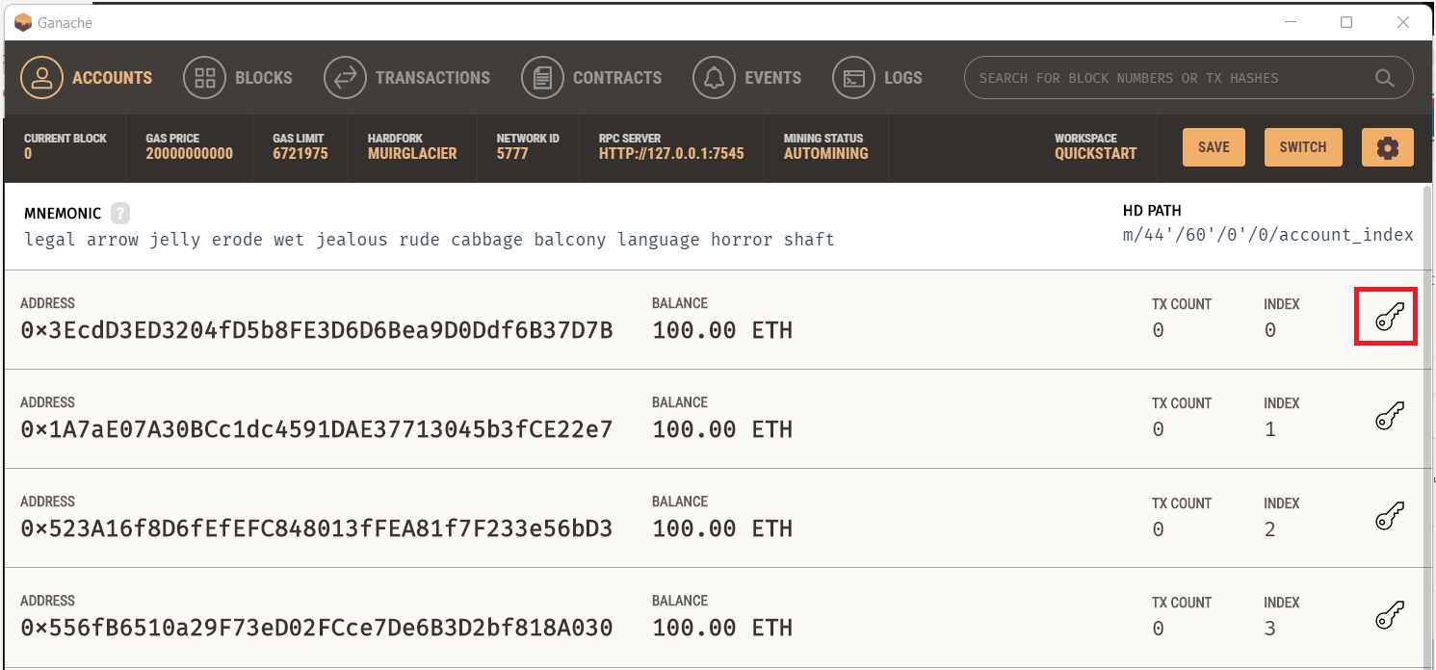

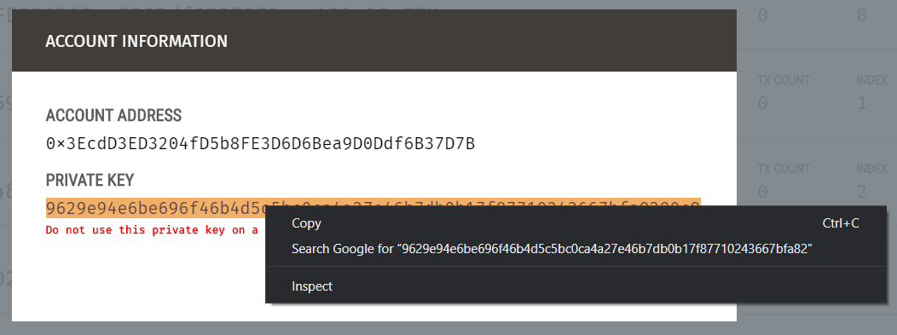

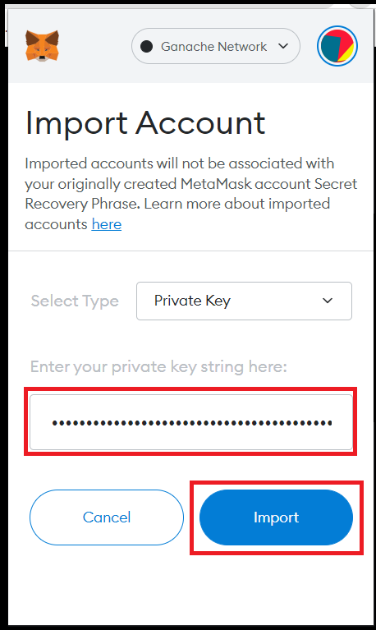

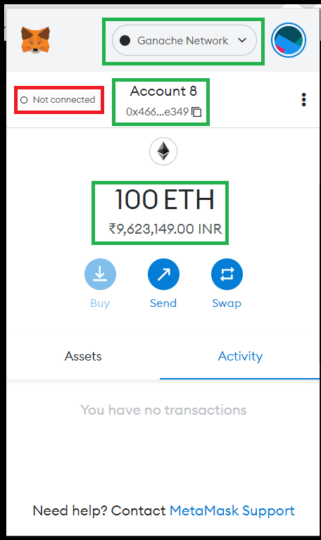

# **Deploy the contracts on to Ganache Test Blockchain and verify**

**truffle migrate - -reset**

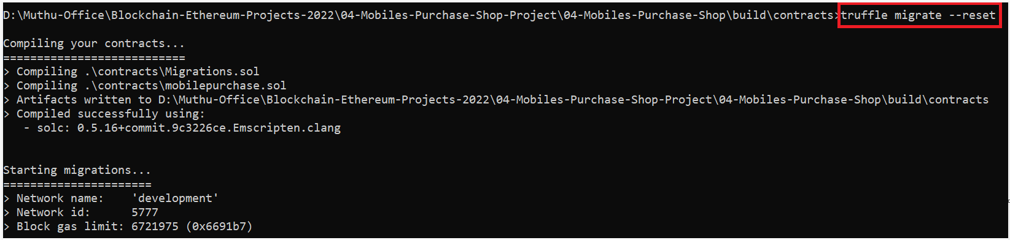

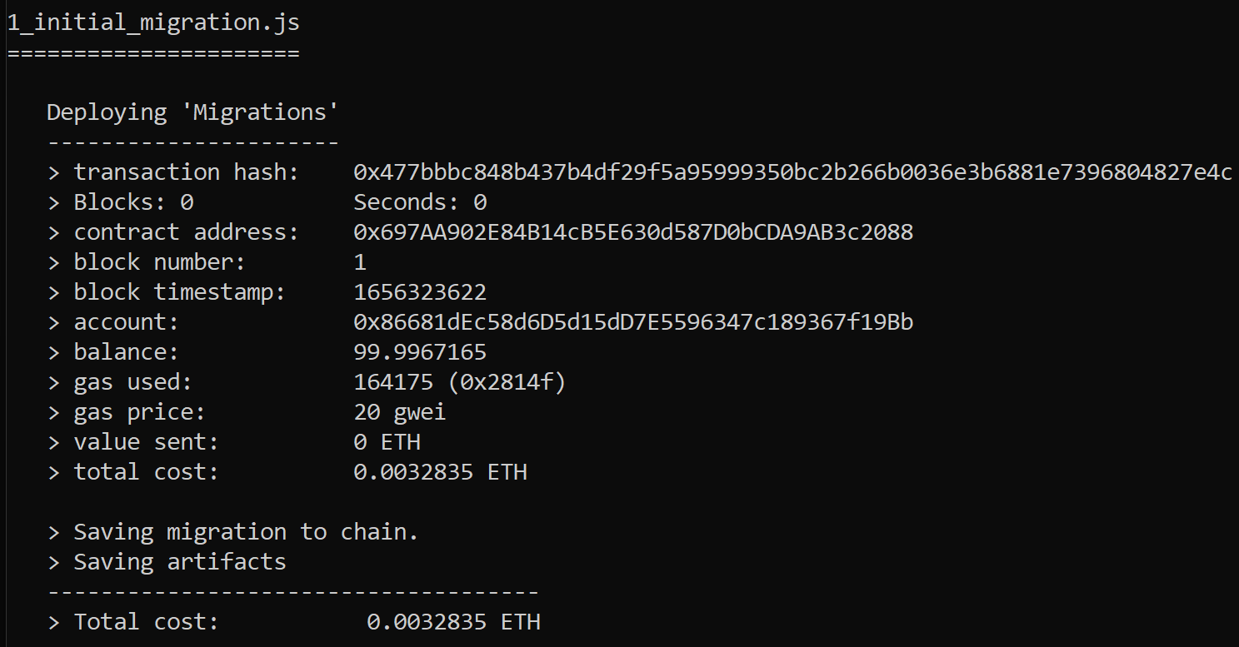

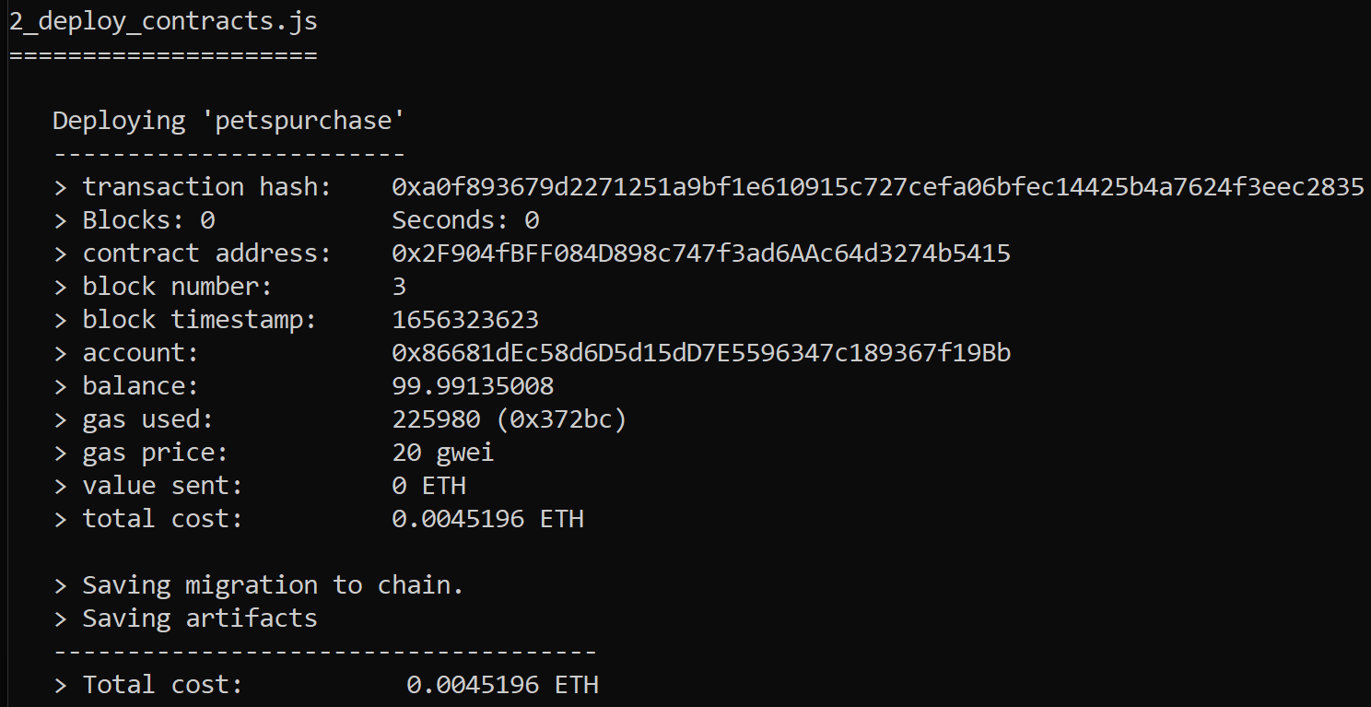

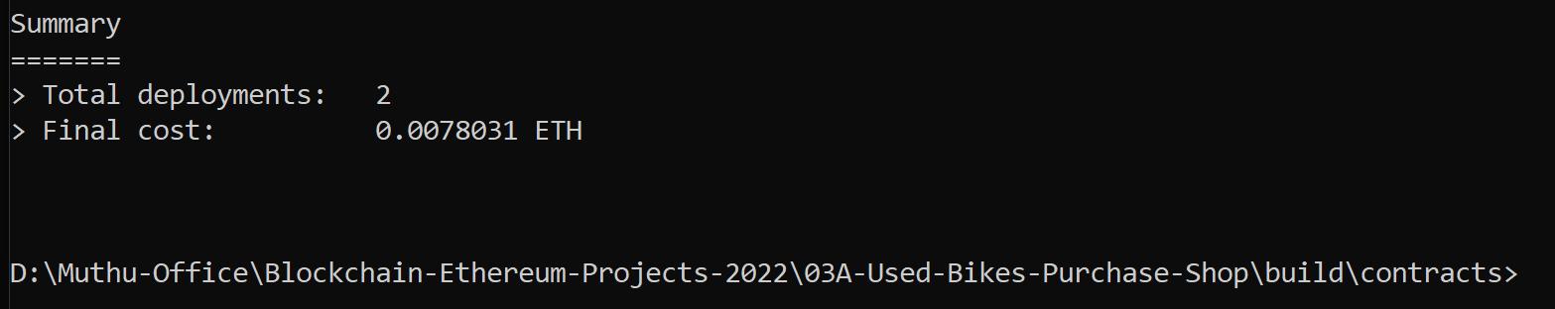

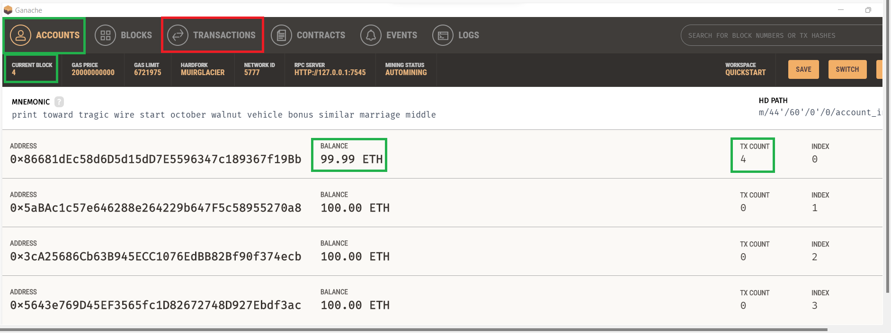

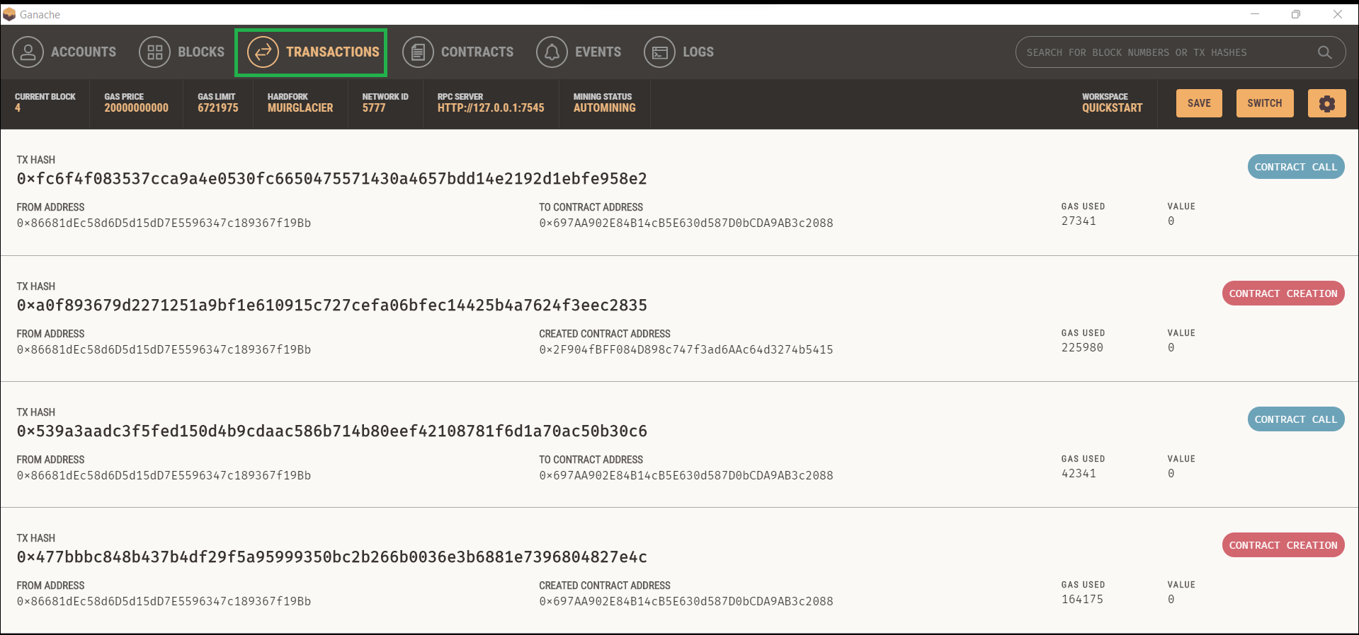

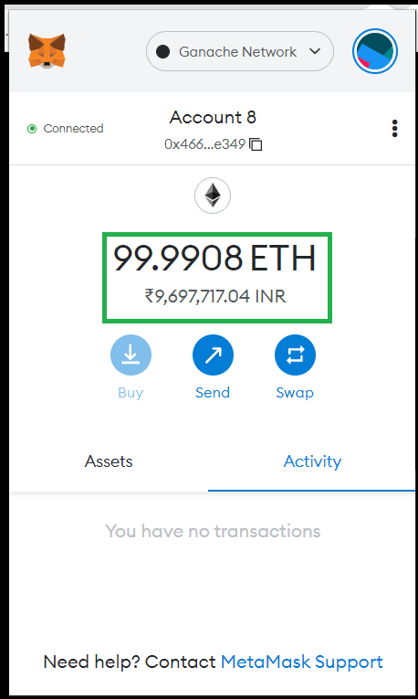

# **Start the Dev Server and verify the deployment of the project’s frontend**

# **Start the Dev Server (lite-server)**

**npm run dev**

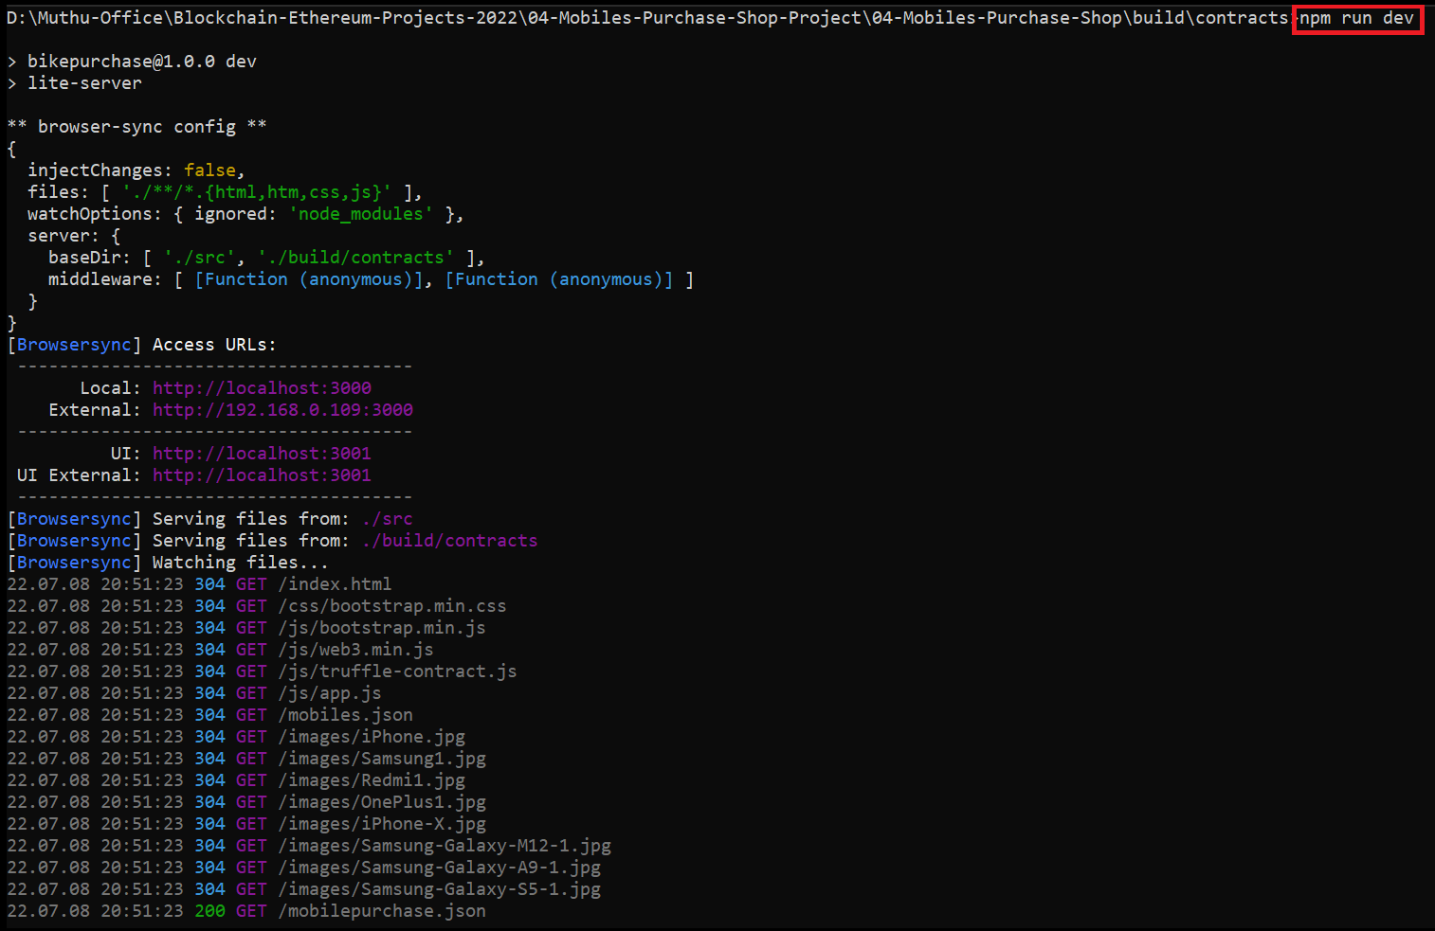

# **Verify the display of the Project’s frontend in the Chrome Browser**

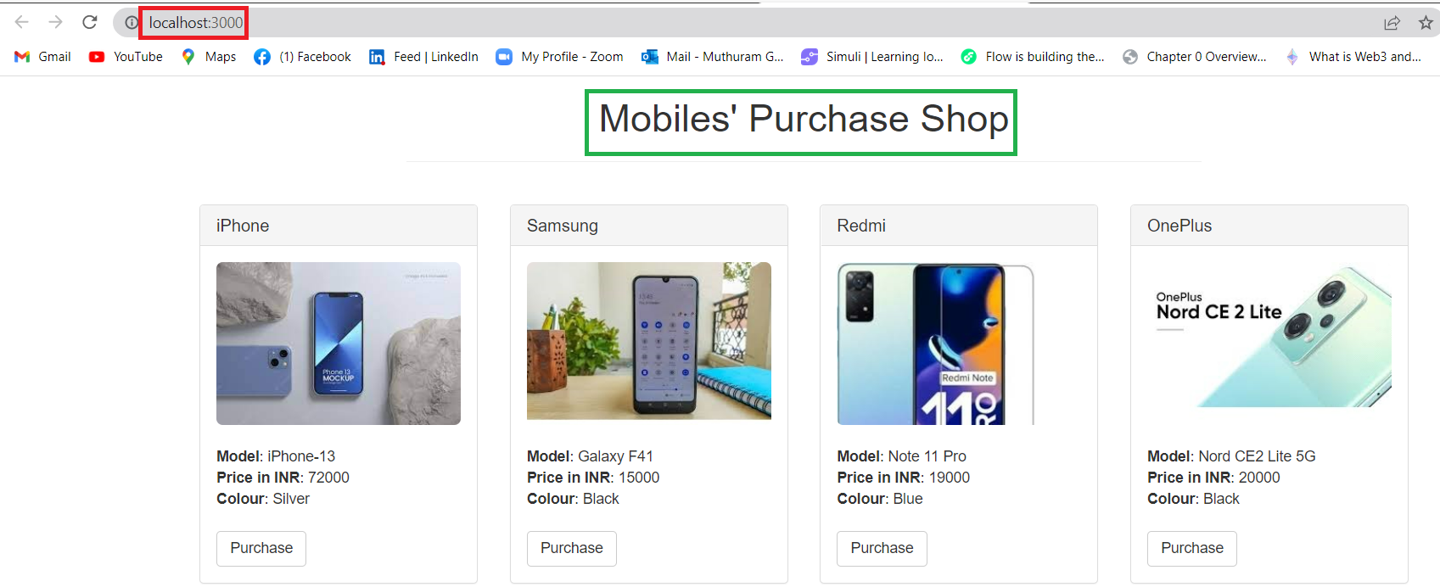

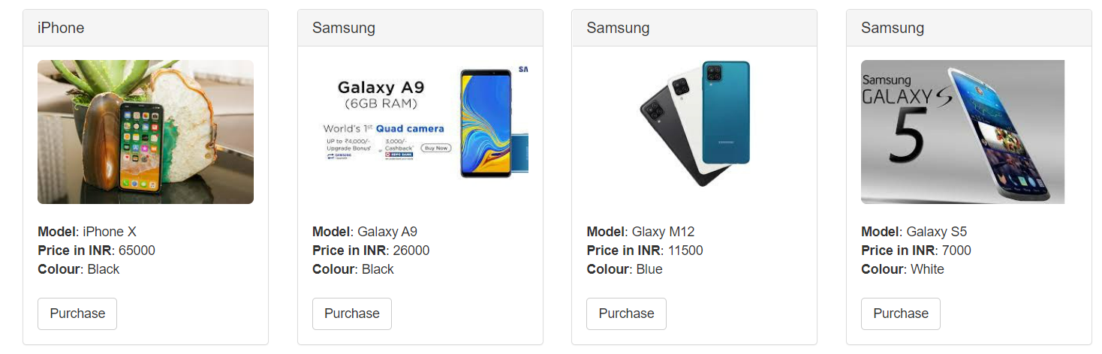

# **Interactions with the “Mobiles Purchase Shop” Project using the frontend**

# **Purchase a “Mobile” using the currently connected Ethereum Account**

## **Click on “Purchase” button given under any one of the Bike pictures**

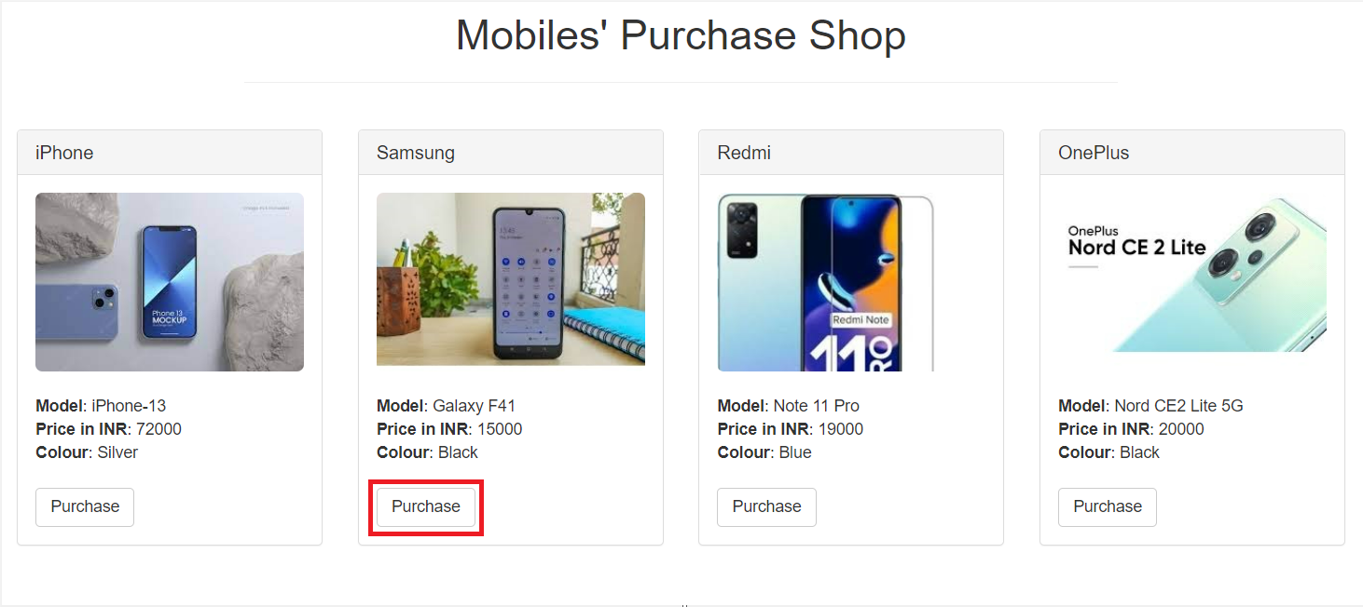

## **Check on the Metamask account displayed and make sure that your recently imported account is displayed and it is loaded with 100 Ethers.**

**Note: If your recently imported account is not displayed means that account is not active with the Ganache Test Blockchain. Make sure that that account becomes active.**

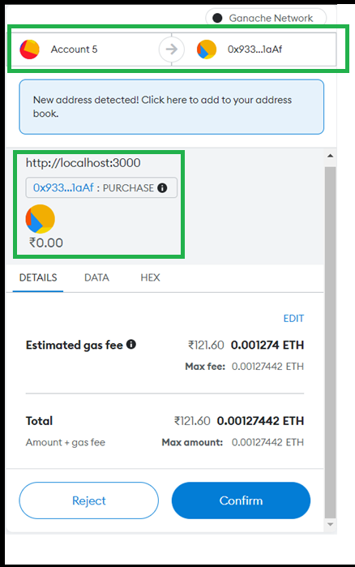

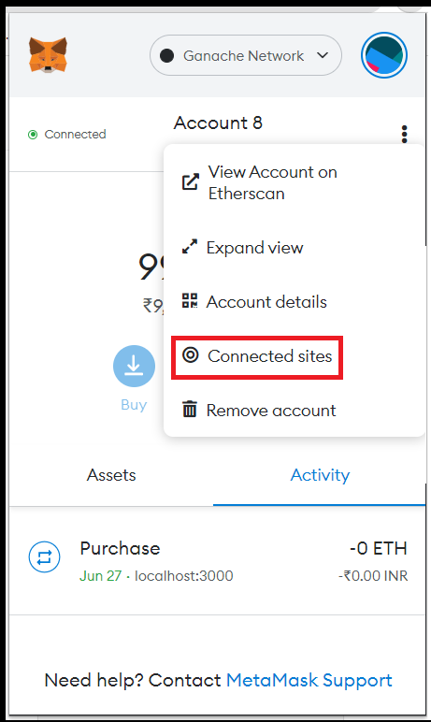

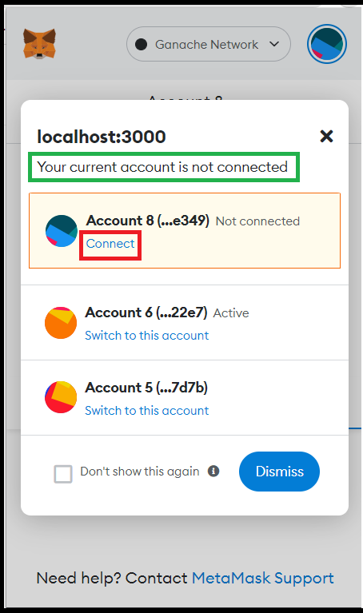

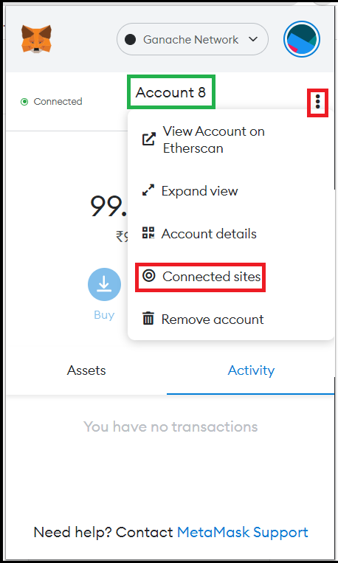

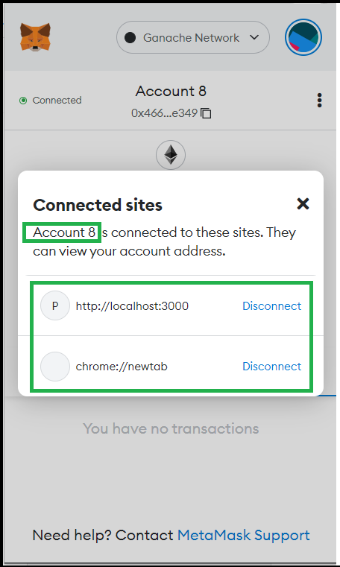

## **Now, click on “Purchase” button given under any one of the Bike pictures**



## **Verify the Metamask Wallet display (like Account Info, Estimated Gas Fee, Total Fees) and then click on “Confirm” button.**

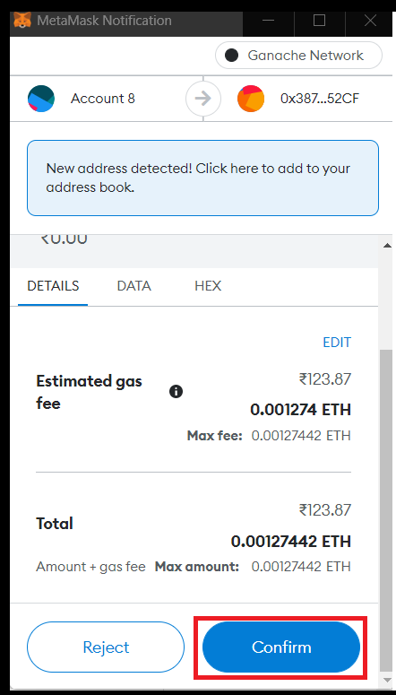

## **Verify that the clicked “Purchase” button is changed to “Success”. The Ethereum Account info is displayed under Purchaser.**

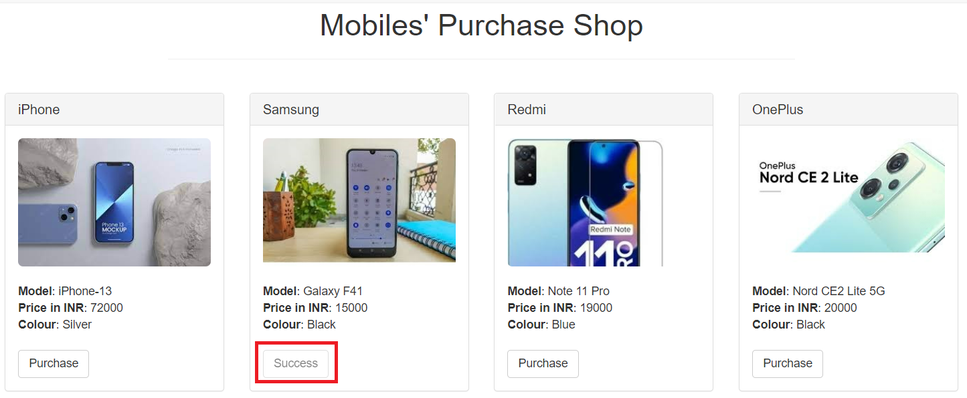

## **Verify the Ganache TX COUNT, Transaction and New Block Creation**

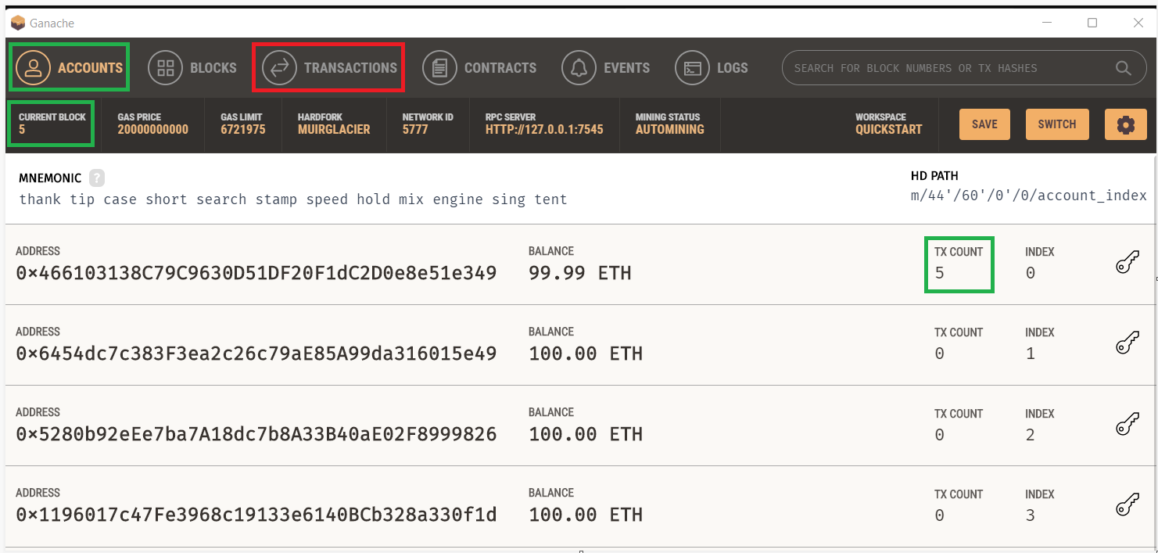

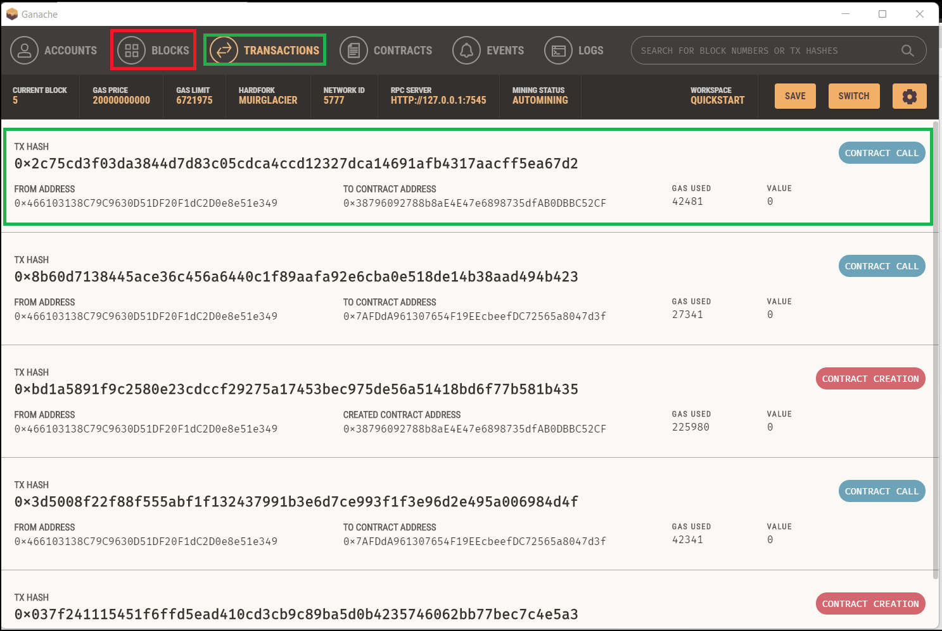

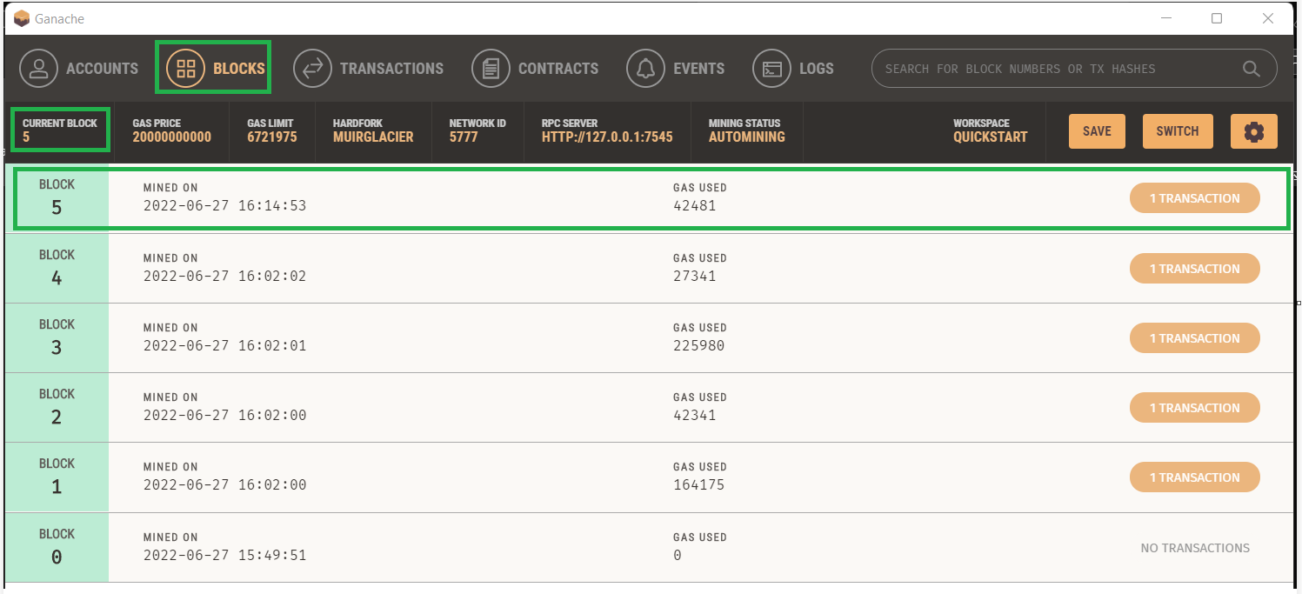

# **Purchase a second “Mobile” with the same Ethereum Account**

## **Click on “Purchase” button below any of the Mobile pictures which has not been purchased so far**

**Note-1: You cannot purchase a Mobile which has already been purchased**

**Note-2: With the same Ethereum account you can purchase more than one Mobile**

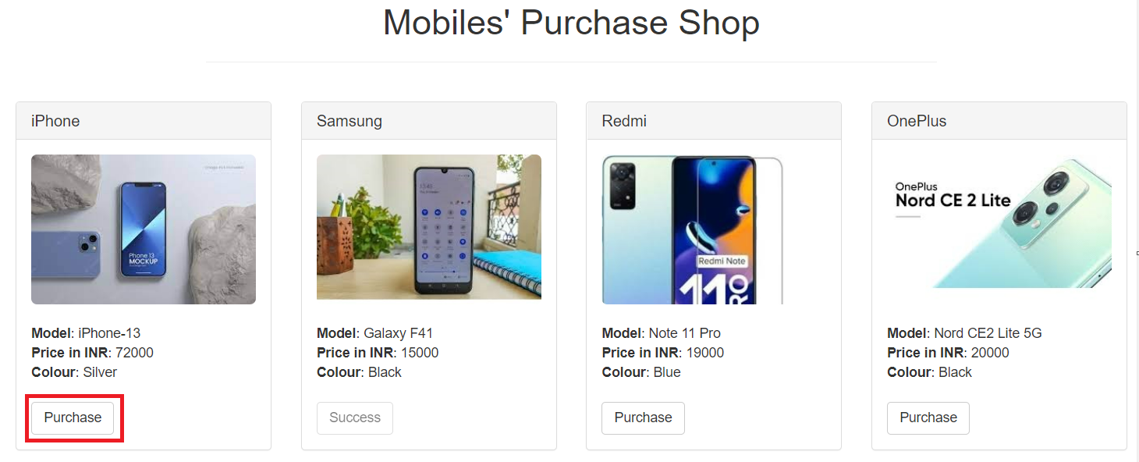

**b) Verify the Metamask Wallet display (like Account Info, Estimated Gas Fee, Total Fees) and then click on “Confirm” button.**

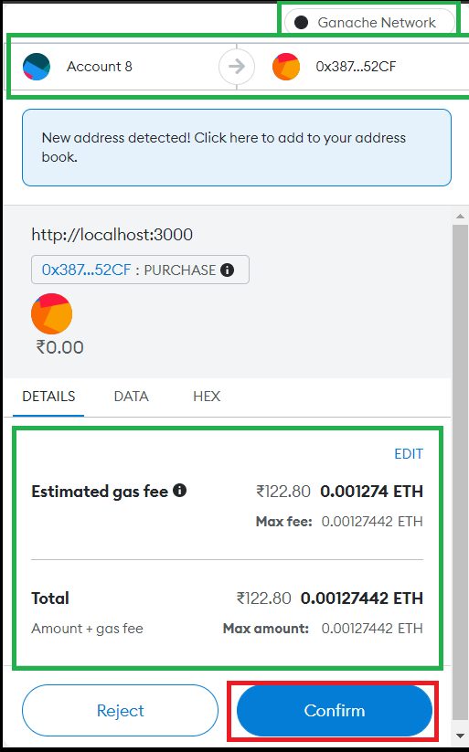

## **Verify that the “Purchase” button has changed into “Success”.**

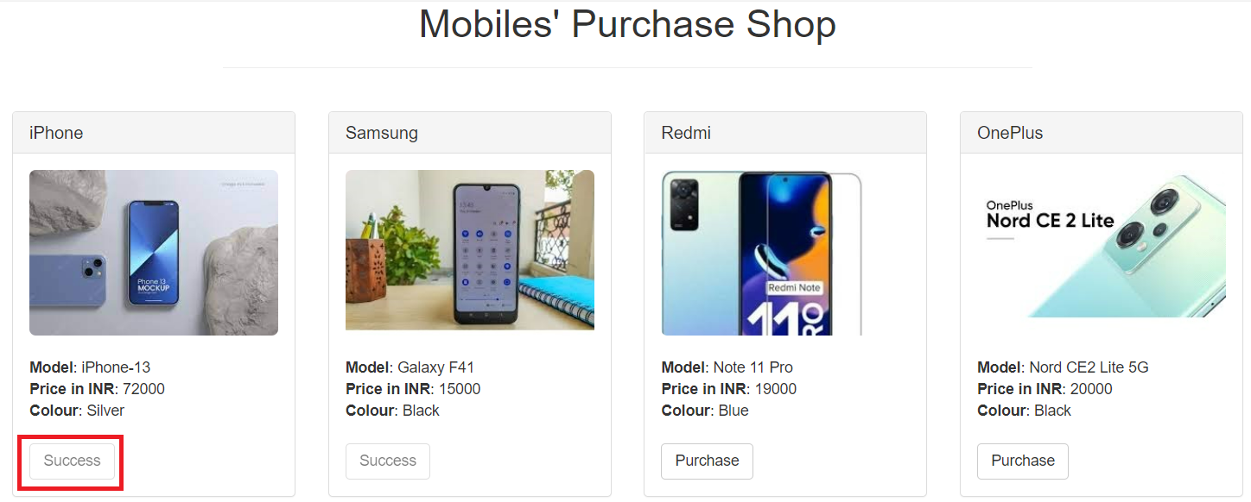

## **Verify the Ganache TX COUNT, Transaction and New Block Creation**

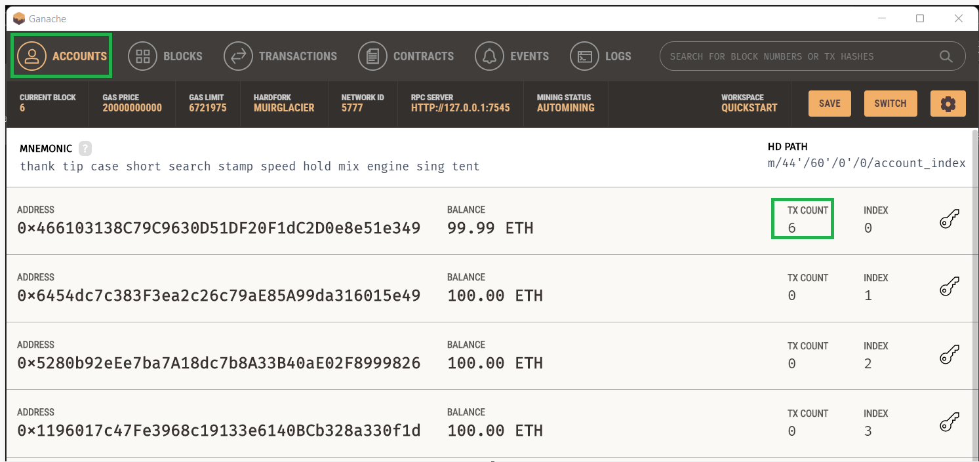

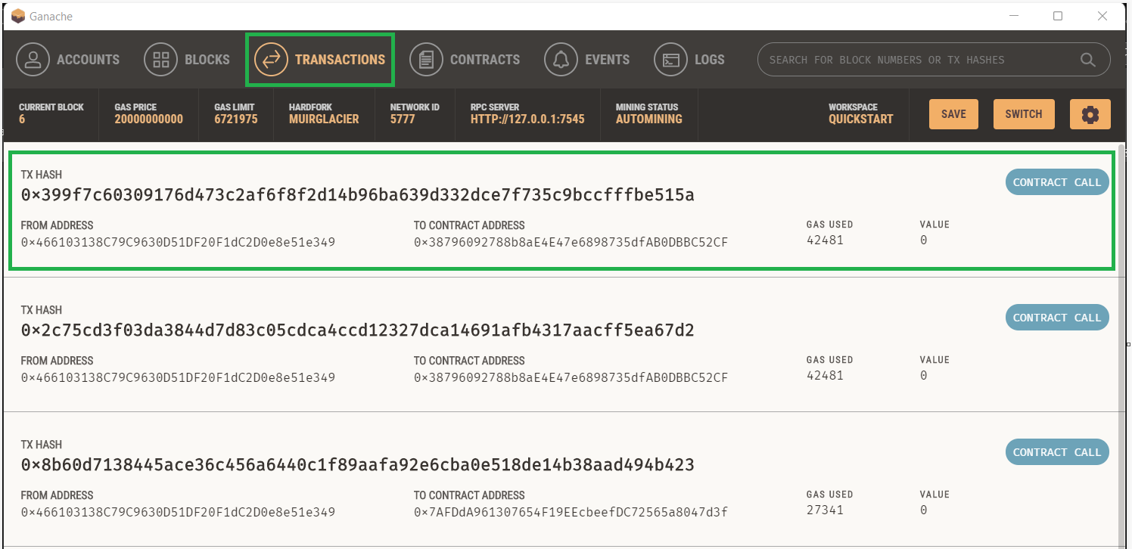

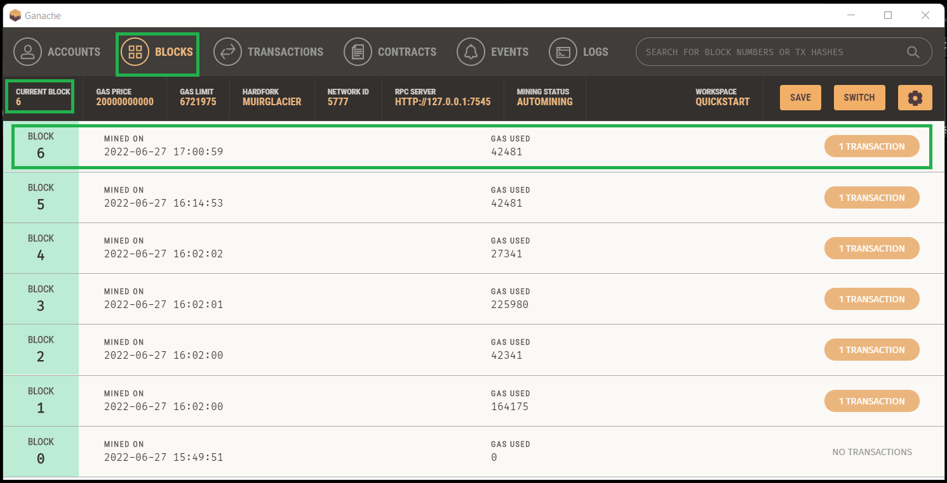

# **Purchase a “Mobile” with the another Ethereum Account**

## **Copy the Private key of the Second Ethereum account in Ganache**

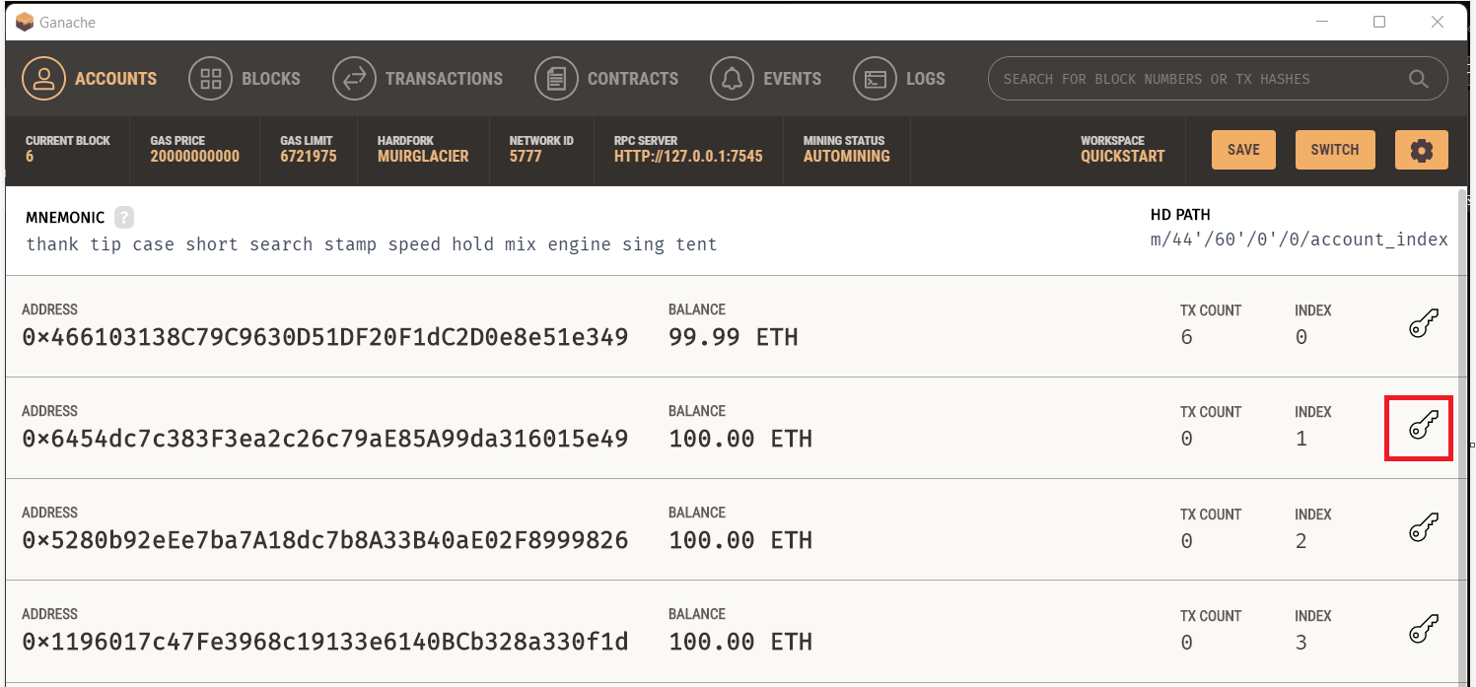

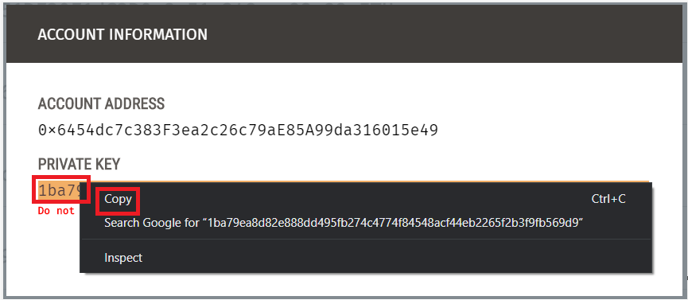

## **Select the “Ganache Network” in the Metamask, import an account, paste the just copied Private Key and click on “Confirm” button**

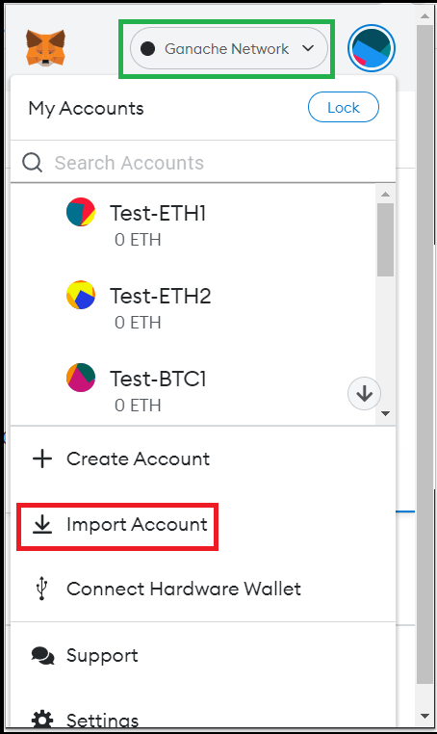

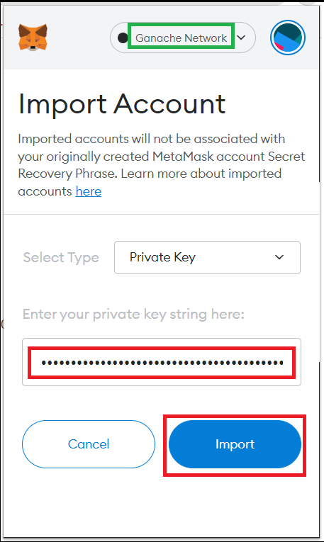

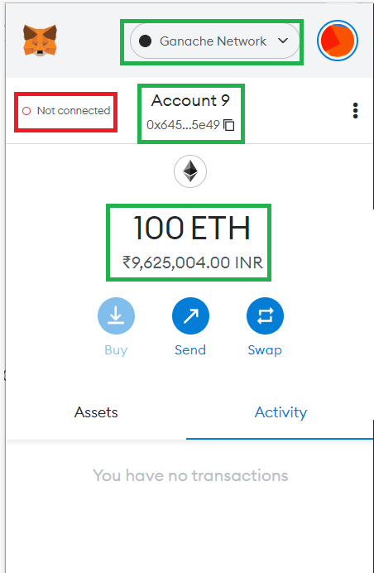

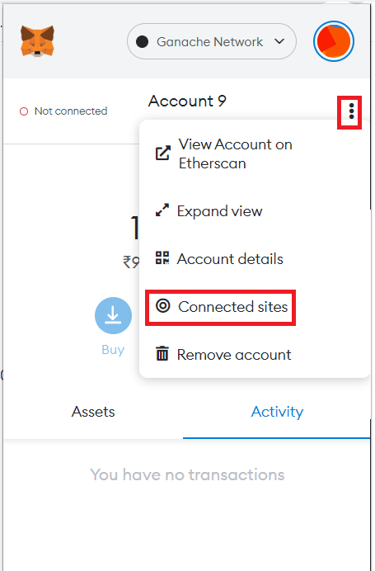

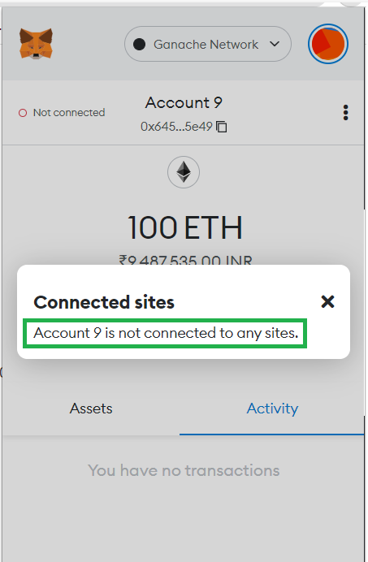

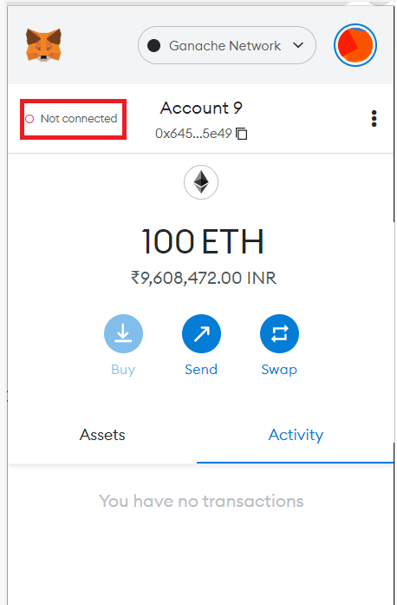

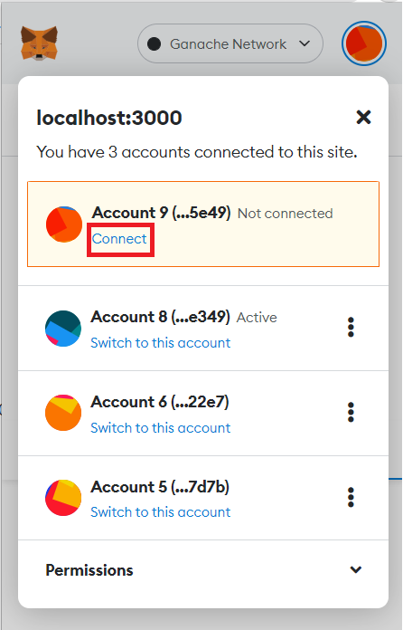

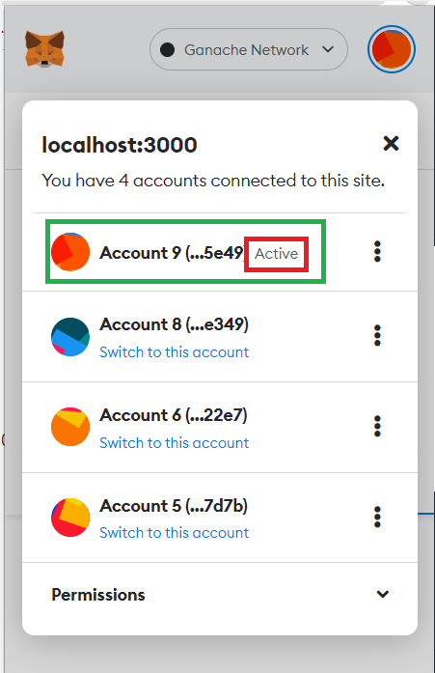

## **Click on “Purchase” button given under any one of the Mobile pictures which has not been purchased so far**

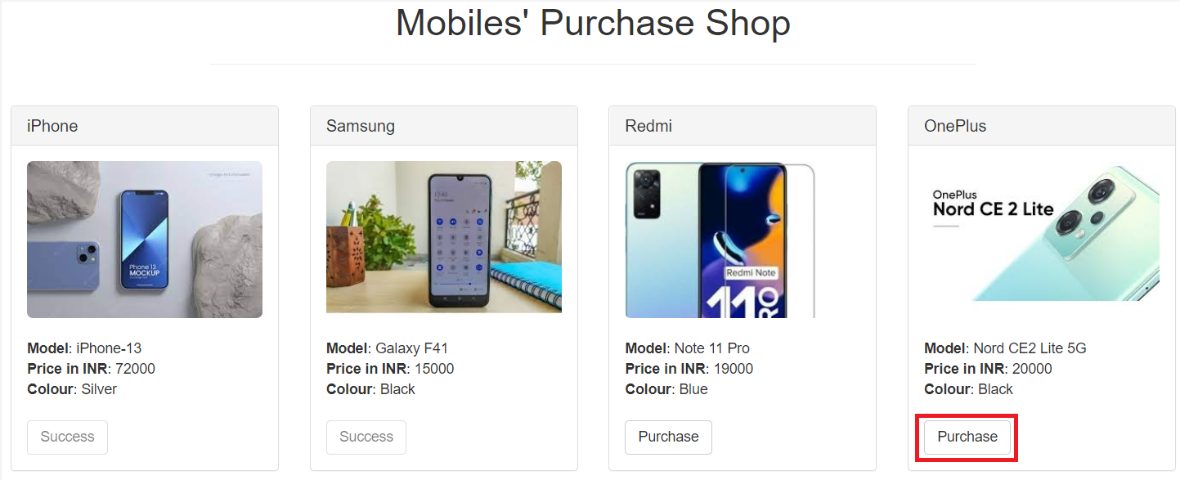

## **Click on “Confirm” button in the Metamask**

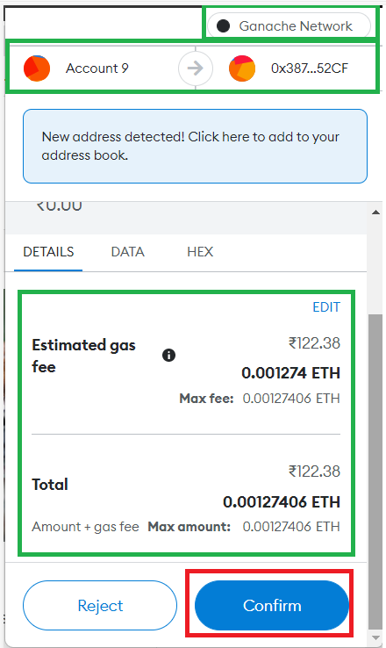

## **Verify that the “Purchase” button has changed into “Success”**

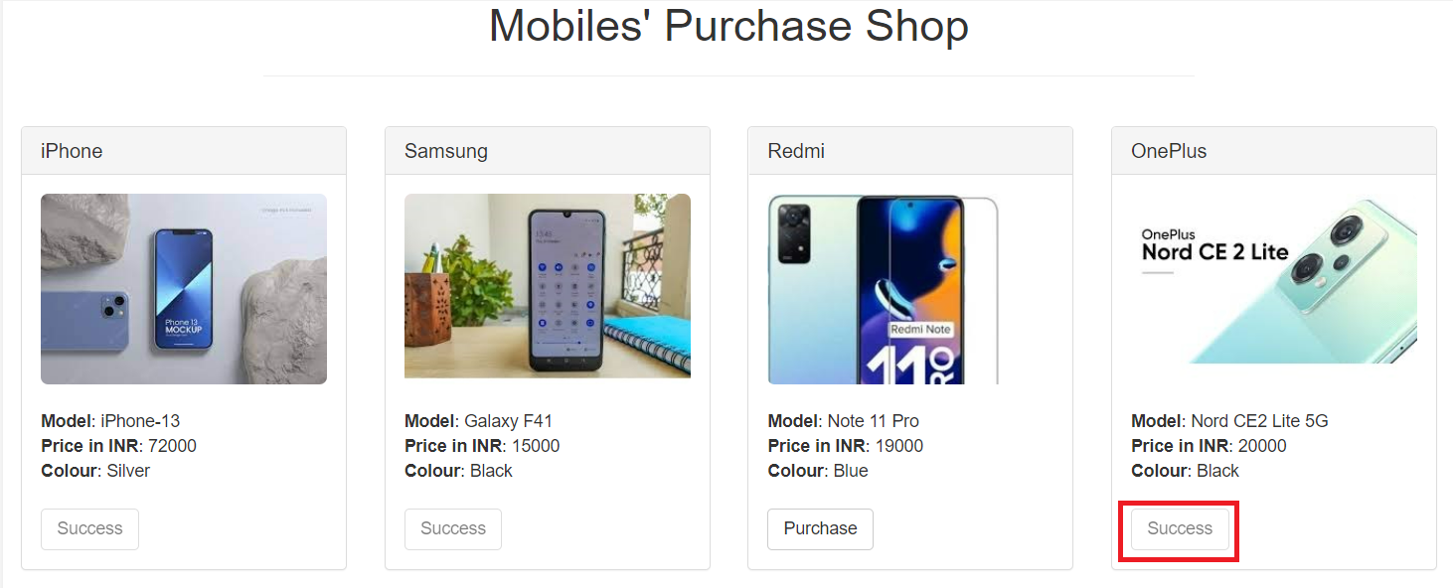

## **Verify the Ganache TX COUNT, Transaction and New Block Creation**

